

# ArcGIS Pro DNR Cross Section Tool

User Manual for Groundwater Technical Analysis

ArcGIS Pro

04/02/2025

## About

The cross sections created using this tool allow for visualization and comparison of well construction, well lithology, water level elevations, and pump settings. This toolbox has been constructed for use by DNR staff working on permit reviews and well interference investigations. The toolbox is meant to take the place of the DNR Groundwater Tool Add-In for ArcMap as the enterprise migrates to ArcGIS Pro. Each tool and its use are described below.

### Disclaimers

* The cross sections created using this tool use data from the County Well Index (CWI). The CWI database does contain errors and all information should be vetted prior to finalizing cross sections.
* Data obtained from the CWI database contains **Non-public information**.
  + Exact locations of public water supply wells - This includes all wells with the use codes MU, PC, PN, PP, and PS.
* Cross-sections created using Unverified well locations are not suitable for all applications.
* All cross sections that include geologic or hydrogeologic interpretations are required to be developed under a Professional Geoscientist (PG).

## Contents

About 2

Disclaimers 2

Contents 3

Versioning and Extensions 5

Starting A New Project 5

Layout Templates 6

Grid Files 8

Add the DNR Cross Section Toolbox to ArcGIS Pro 8

Sourcing Your Data 9

Coordinate Systems 9

CWI Database 11

DEM rasters 11

Storing Your Data 13

Cross Section Lines 14

Using the Toolbox 19

Before Beginning 19

1 Create Raster Profiles 19

Verified and Unverified Wells Toolsets 21

2 Get CWI Data / *Get Unloc CWI Data* 22

3 Clean CWI Data / *Clean Unloc CWI Data* 23

REVIEW OUTPUT DATA BEFORE PROCEEDING! 24

Editing Well Data 25

Editing Well Locations 25

Adding New or Missing Data 26

Removing Wells 31

For Combined Verified and Unverified 2D Outputs 32

4 Make Lixpy Diagrams/ *Make Unloc Lixpy Diagrams* 33

5 Create Conspy Diagrams / *Create Unloc Conspy Diagrams* 34

6a Create 2D Well Points / *Create Unloc 2D Well Points* 35

6b Create 2D SWL Points / *Create Unloc 2D SWL Points* 35

6c Create 2D DPL Points / *Create Unloc 2D DPL Points* 36

Extras 37

7 Create Vertical Lines at Intersections 37

Formatting the Cross sections 39

Protecting Non-public Information 39

Editing 2D Output Files 39

Format the well construction file 40

Format Verified well lithology file 40

Format the Unverified and Combined well lithology files 41

Add the pump setting information 41

Create polylines or polygons to illustrate lithology 41

Format the legend 42

Format the Cross Section PDF 42

## Versioning and Extensions

Before beginning, make sure you have:

* Installed ArcGIS Pro version 3.3 with Advanced license.
* Enabled the following ArcGIS Pro extensions.
  + Spatial Analyst
  + 3D Analyst

The latest version of ArcGIS Pro can be installed via Software Center.

To enable the ArcGIS Pro extensions, submit a ticket to MNIT GIS Team requesting that the extensions be enabled for your personal ArcGIS Pro license. A supervisor’s permission is not required.

## Starting A New Project

Each project/permit should have a separate ArcGIS Pro project (.aprx) for cross sections.

1. To create a new cross section project, open ArcGIS Pro. On the Start Screen, click on the “Start with another template” button on the right-hand side.

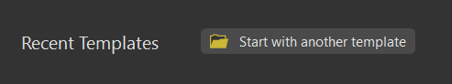

* Navigate to “V:\gdrs\apps\org\us_mn_state_dnr\DNR_CrossSection_Tool\ProjectTemplates” and select the “Pro_DNR_CrossSection_TemplateVxx.aptx ” file. Click OK.

1. A “Create a New Project” dialog box will open. Rename your project appropriately ([Permit #]-[Project Name]-XS Ex: 2001-0001-RainbowFarms-XS) and set your preferred location on a local drive but NOT buried deep in your file tree. The longer the file path, the more trouble you’ll have. ALSO, IT IS CRITICAL THAT YOUR PROJECT IS NOT STORED IN A FOLDER AUTOMATICALLY BACKED UP BY ONE DRIVE. Click OK.

* Your new project should have two maps and two layout options (letter and tabloid sizes) open as shown below.

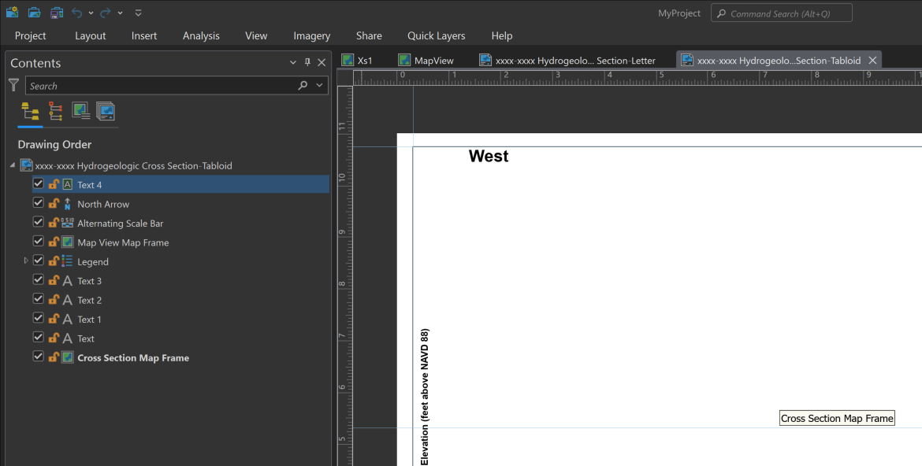

### Layout Templates

Two layout templates are included in the project template by default. One is for letter-sized paper, the other for tabloid-sized paper. Choose whichever size works best and is approved by your PG.

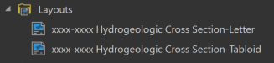

1. To use a layout, open the Table of Contents for the new layout window. Right click on the Map View Map Frame and select Properties.

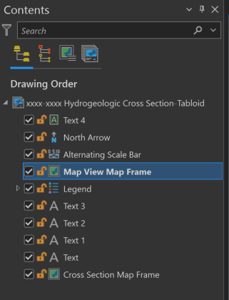

1. In the Element window, change the Map in the Map Frame drop down menu from “<None>” to “MapView”.

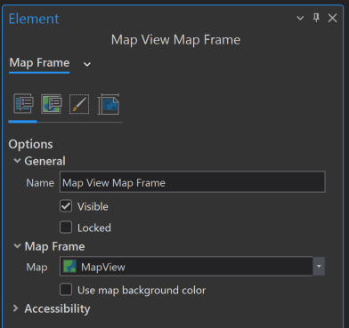

1. Repeat the same steps for the Cross Section Map Frame to populate the new layout with “Xs1”.

### Grid Files

These files provide the grid line, polygon, and point label files for traditional cross section display, with the beginning of the cross section always at measure zero. These files should never be altered and are saved in the ‘grid2011.gdb’. If the file connection breaks, navigate to “V:\gdrs\apps\org\us_mn_state_dnr\DNR_CrossSection_Tool\GridFiles” to reconnect.

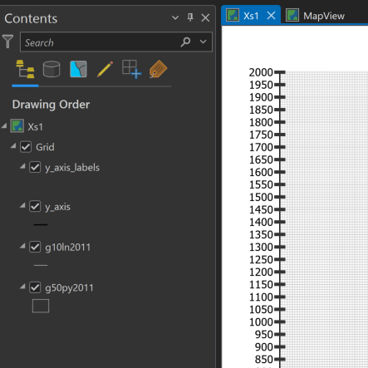

### Add the DNR Cross Section Toolbox to ArcGIS Pro

The DNR Cross Section Tools is a toolbox available for use in ArcGIS Pro by staff at DNR.

1. If the toolbox is not already available in your new ArcGIS Pro .aprx document, go to Catalog > Favorites > Add Item > Toolbox > Add Toolbox.
2. Navigate to “V:\gdrs\apps\org\us_mn_state_dnr\DNR_CrossSection_Tool ” and select “DNR Cross Section Tools [most recent version].tbx” then click OK.
3. The toolbox should now be visible in both the Favorites and Project tabs of the Catalog. In the Project tab, expand the Toolboxes folder to view.

## Sourcing Your Data

### Coordinate Systems

#### Tool Inputs

* Mapview data such as cross section lines and DEM rasters must be in the Projected Coordinate System NAD 1983 UTM Zone 15N. This coordinate system is available in ArcGIS Pro’s default coordinate system library.

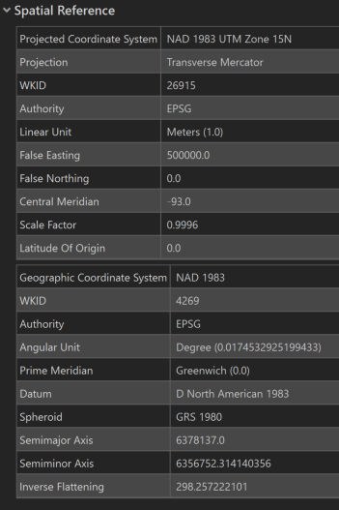

#### 2D Tool Outputs

* Two-dimensional tool output files are automatically produced with two different spatial references.
  + “Unknown Coordinate System”
    - This indicates a lack of coordinate system. These files can be opened in any version of ArcMap or ArcGIS Pro, but cannot be edited in ArcGIS Pro.
    - 
  + “DNR_XS_x_x” projection file is available for use, or you may use your own.
* The DNR_XS_... projection file is made-up custom coordinate system for projecting 2D cross section tool outputs. Feature classes using this coordinate system may not be openable with any version of ArcMap or ArcGIS Pro; however, they can be edited. The version number at the end of the projection file name indicates the version of ArcGIS Pro for which it was created (i.e. DNR_XS_3_3.prj was created in ArcGIS Pro version 3.3).
* During toolbox beta testing, ArcGIS Pro software updates made a beta version of a 2D projected coordinate system .prj file unopenable. I cannot predict if or when this will happen in the future. If needed, new custom 2D .prj files compatible with newer versions of ArcGIS Pro will be published.
* This coordinate system is NOT available in ArcGIS Pro’s default coordinate system library. The projection file defining this coordinate system is saved here “V:\gdrs\apps\org\us_mn_state_dnr\DNR_CrossSection_Tool ”. In Windows explorer, the file name will appear as “HCS_Custom_DNR_XS_x_x.prj”.

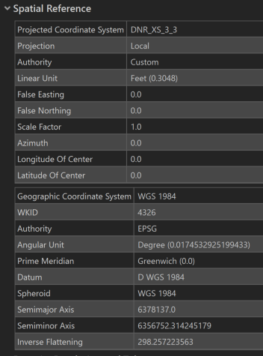

### CWI Database

* **Minnesota County Well Index**
* The [Minnesota County Well Index (MWI)](https://mnwellindex.web.health.state.mn.us/mwi/) provides basic information about location, depth, geology, construction and static water level, for many wells and borings drilled in Minnesota. It by no means contains information for all the wells and borings and the absence of information about a well on a property does not mean there isn’t a well on that property.
  + For detailed information about the tables, fields, and codes within the database, visit the [Database Dictionary website](https://mgsweb2.mngs.umn.edu/cwi_doc/cwiDataTables.htm).
  + **Wells with verified locations:**
* The default data source for the tool scripts is a Spatial Database Engine (SDE) connection file saved on the V: drive. This SDE file is read-only, connects to the CWI database and automatically updates daily.
  + **Wells with unverified locations:** 
    - A separate geodatabase on the DNR V: drive contains a point feature class with estimated well locations for unlocated wells. These estimated locations were generated by converting PLS data to UTM coordinates. This point feature class is not available within the CWI database.
    - Estimated locations will likely need to be adjusted and the UTM coordinate fields updated to reflect the changes.
    - Data tables for these wells are obtained from the CWI database via the same SDE file as the Verified Location wells.

### DEM rasters

All rasters must be renamed WITHOUT special characters or spaces before running the toolbox tools.

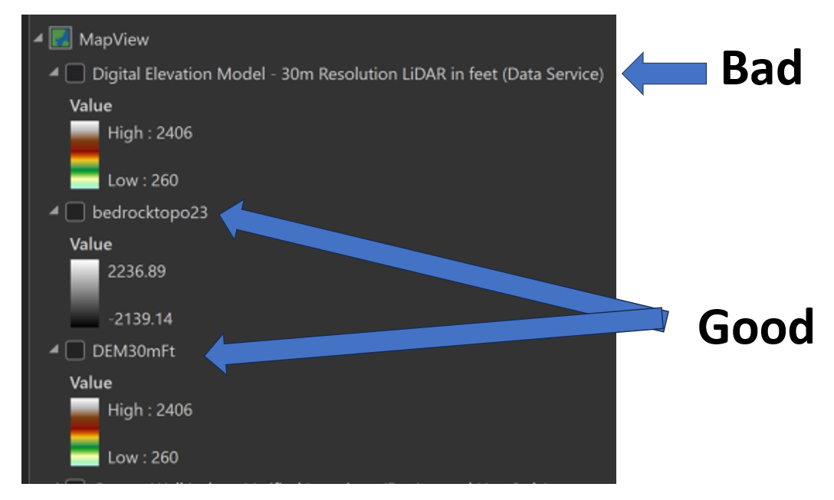

#### Surface Topography

* Best practice:
  + Use lower resolution DEMs (i.e. 30m) for land surface profiles for lines longer than 1-2 miles (Tool 1)
  + Use higher resolution DEMs (i.e. 1m or 3m) for extracting well surface elevations (Tool 2 in either verified or unverified toolsets)
    - The DEM used to extract well elevations MUST be named “dem”
* DEMs of any resolution from Quicklayers may be used as long as the following criteria are met:
  + The vertical values are in feet
  + The layer is a “Data Service” layer
  + The layer is renamed WITHOUT spaces or special characters after bringing it into your map
* 30-meter DEM example:
  + Add the “Digital Elevation Model - 30m Resolution LiDAR in feet (Data Service)” layer from Quicklayers to your Map View pane in ArcGIS Pro.
  + In the table of contents, right click the DEM layer and select Properties.
  + In the Layer Properties dialog box on the General tab, change the Name of the layer to “dem30mft” or similar and click OK.

#### Statewide Bedrock Topography

* For transects that span multiple counties, download a copy of the [MGS Bedrock topography DEM](https://www.arcgis.com/home/item.html?id=c59c0e1dd4d0491685a2fd4dfcc42d45) to your computer and add it to the MapView window.
  + If the above link breaks, go to this site: <https://mngs-umn.opendata.arcgis.com/pages/spatial-datasets>
  + Click on the D-Series Downloadable Data drop down menu and select D-4, Bedrock Topography.

**County Geologic Atlas Grids**

* If county atlas grids are available for your project area, you may want to include them in your cross section.
* Part A data is available on the I: drive at I:\EWR\_IMA\HGG\ATLAS\Author_Resources\Data\PartA
* Make sure the grids are in the correct projection (usually NAD 1983 UTM Zone 15N) before proceeding.

### Storing Your Data

Projects may be organized differently depending on cross section line (also referred to transect or cross section line throughout this document) orientation.

* Project data used across multiple cross sections should be stored in a general project geodatabase (ex: RainbowFarms.gdb).
  + Data examples:
    - mapview cross section line feature class containing all cross section lines for the project
    - mapview well points not available in CWI that are manually added
    - corresponding stratigraphy, construction, static water level, and drop pipe records for manually added wells

#### Non-overlapping lines

* If cross section lines and/or line buffers for a single project or site **DO NOT overlap**, all tool inputs and outputs may be stored in the same ArcGIS Pro project geodatabase. Multiple lines can be processed in batch, requiring each tool step to only be run once.

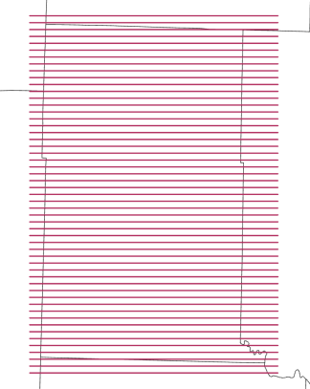

#### Overlapping lines

* If cross section lines or buffers for a single project or site **DO overlap**, it is best practice to store tool inputs and outputs in a separate geodatabase for each line. For example, for a project with 5 cross section lines, you will need at least 5 geodatabases. The tool automatically overwrites existing data if the file names have not been manually changed, so separation can help prevent accidental data loss. (ex: RainbowFarmsXs1.gdb, RainbowFarmsXs2.gdb, etc.). Of course, you can also change the output file names as you go and keep all data for all cross sections in a single database.

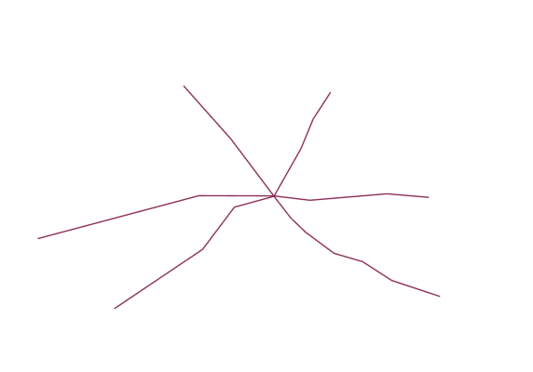

### Cross Section Lines

In this step you will prepare the cross section lines (a.k.a traces or transects) in the Map View data frame. These can be a straight lines or lines with many vertices that “zigzag” through the wells of interest.

##### Notes and Best practices

* The first location clicked on the map will be the left edge of the cross section the tool creates.
* Cross sections should always be digitized from West to East (if horizontal) or South to North (if vertical).
* It helps to begin digitizing your cross section line slightly to the West (or South) of the first well or

site of interest. This will prevent that feature from being covered up by the vertical axis displayed on the cross section using the DNR Groundwater Tool. The same is true for the last point digitized of the polyline.

* Every click of the cursor creates another vertex in the cross-section line.
* Each cross section line must be single part, or the tool will fail.
* Keep wells of interest within ½ mile (805 m) of the cross section line.
* Be wary of creating sharp right angles within a single line, as this can cause unexpected data omissions.

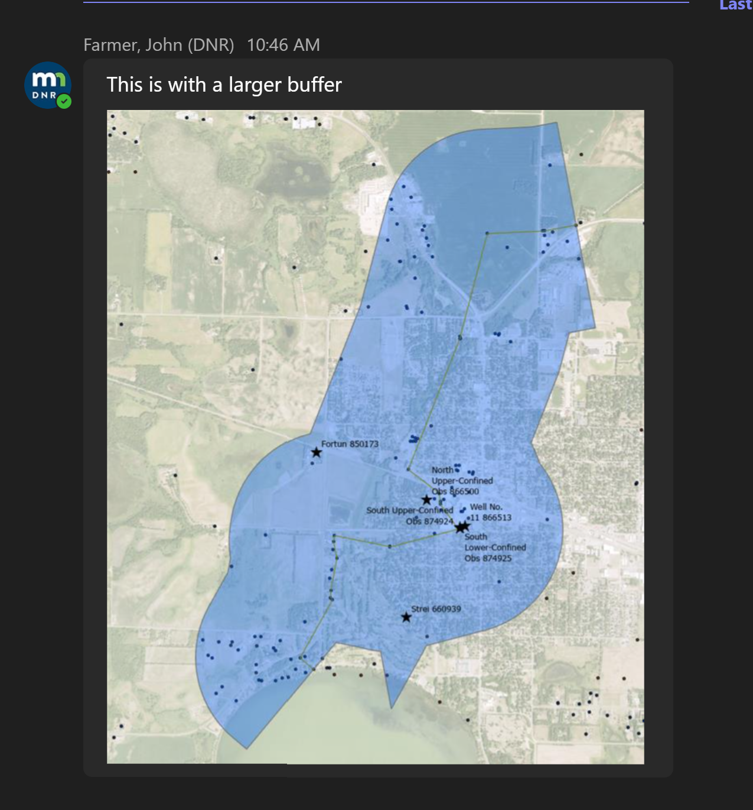 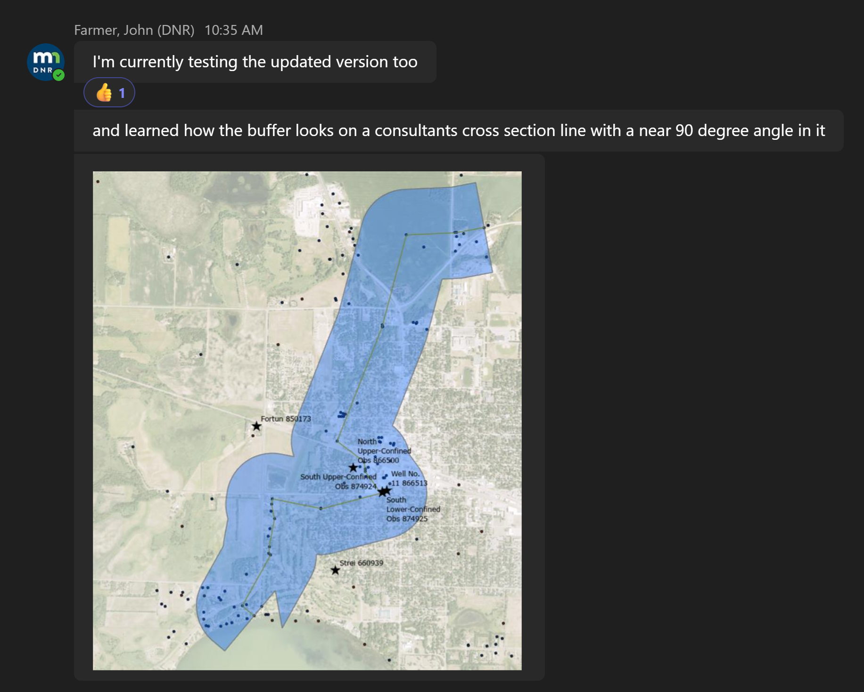

#### Import existing polyline files

If you already have cross section line in a .shp or feature class in another .gdb:

1. Import them into your cross section .gdb,
2. Add the required fields discussed below if they are not already present,
3. Remove any unnecessary fields that may be present from your newly imported feature class attribute table.
4. Review the “Notes and Best Practices” section and edit the imported lines as needed to meet those requirements.

#### Create a polyline feature class

1. To create a new feature class, open ArcCatalog and locate your cross section geodatabase.
2. Right‐click on the .gdb and select New Feature Class. Name it “xsln_mapview” and select “Line” from the Feature Class Type dropdown menu. Make sure both Geometric Properties boxes are unchecked. Click Next.

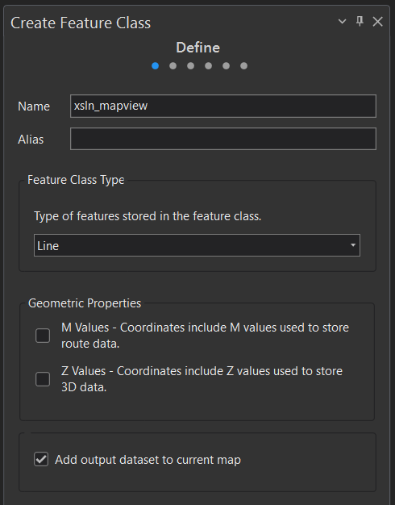

1. Add the following two fields: [xsec_id] and [xsec_desc], both with text data type. Click Next.
   1. Note: [xsec_desc] field is optional but encouraged.

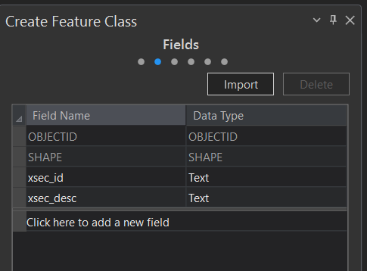

1. Select Projected Coordinate System NAD 1983 UTM Zone 15N. Click Finish.

#### Digitize the cross section lines

#### Draw lines

1. Open the MapView window and bring the “xsln_mapview” feature class into the Contents pane.
2. To digitize the cross-section lines, click on the Create button on the Edit ribbon. This will open the Create Features pane.
3. Click on the “xsln_mapview” file in the Create Features pane and then click on “Line” which should appear in a “Construction Tools” subpane. The cursor should now change to a cross hair that allows you to digitize the polyline.
4. Click on the map to add a starting vertex for your polyline.
5. Straight polylines are created using only two vertices. Click once to start the polyline and then double‐click and the other end to finish digitizing the line. Lines for all cross sections can be stored in this feature class, so continue digitizing the remaining lines.
6. To create a non‐linear polyline with more than two vertices, continue clicking on the map, snapping to wells or sites of interest where appropriate.
7. When finished, click Save in the Edit ribbon.

#### Populate the cross-section line attributes

1. Right‐click on the “xsln_mapview” file in the Contents Pane. Select Attribute Table. Click on the Edit tab at the top of the project window to activate the editing ribbon.
2. Populate the [xsec_id] field with consecutive unique numbers (required), and the [xsec_desc] field with a brief description of the line’s orientation (optional). Click Save.

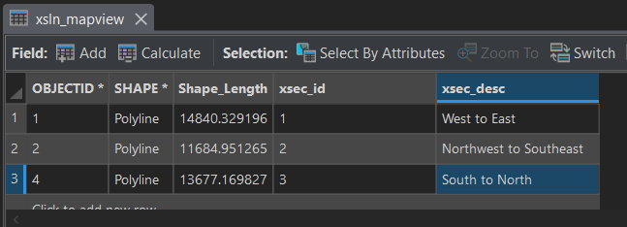

## Using the Toolbox

There are two toolsets in the DNR Cross Section Tool toolbox: one uses only wells with verified locations, the other uses only wells with unverified locations. Tools that are not dependent on well files are listed outside of the Verified and Unverified Toolsets (ex: 1 Create Raster Profiles). Best practice is to run each tool in numerical order.

### Before Beginning

* You must be connected to the network (V: drive) for the tools to work!
* Open the “Xs1” map and verify that the map’s coordinate system is set to the 2D coordinate system of your choosing. Labels will not display if the map coordinate system is “Unknown”.
* **The output .gdb must be** **manually refreshed** in the Catalog pane **after running each tool** to view output files.
* Output files must be manually added to the map from the output geodatabase.
  + Note: yes, this is annoying and inconvenient, but a software issue that doesn’t have an alternative solution at the time this document was written.
* Unless specified, input file names do not have to exactly match those used in these instructions, as long as the files have the required attributes.

### 1 Create Raster Profiles

The primary purpose of this tool is to create elevation profiles for bedrock topography and surface topography, but the tool will draw a profile line on any raster surface.

#### Parameters

* Output geodatabase: gdb for saving output files.
* Input raster(s): tool will accept any raster surfaces, but this tool is generally used for creating bedrock and surface topo profiles
  + Enter all the rasters you would like to create profiles (the tool can extract multiple raster profiles at a time for multiple cross section lines).
  + Vertical units MUST be in feet.
  + Name must not contain spaces or special characters.
* Cross section line file (mapview): cross section lines in map view.
  + Note that unless a single line is selected in map view, a single output file (ex: DEM30mft_profiles2d_25x) will contain 30m DEM profiles for all cross section lines put into the tool, as shown below. Green lines show land surface profiles for each of the 3 cross-section lines in the input file. Purple lines show bedrock profiles for each of the 3 cross-section lines in the input file.
  + To produce profiles for a single line in “xsln_mapview”, make sure the line is selected in mapview before running the tool.
* Cross section ID field (text data type): [xsec_id] or field in “xsln_mapview” that contains unique cross section number. The field MUST BE text data type.
* Vertical exaggeration factor: Must be ≥ 1. Common values to use are 25, 50, or 100. If you change this value, be sure to press the “Enter” key before running the tool. After running the tool, verify in the Geoprocessing History window that the correct value was used.
* Merge output files: check to save all output profiles to a single feature class, instead of individual feature classes for each raster.

#### Output

* For each raster, tool will create:
  + 2d profile in cross section view:
    - Without Merge option: Files are automatically named “RasterName_profiles2d_VEx”
* With Merge option: File is automatically named "all_profiles_2d_VEx"

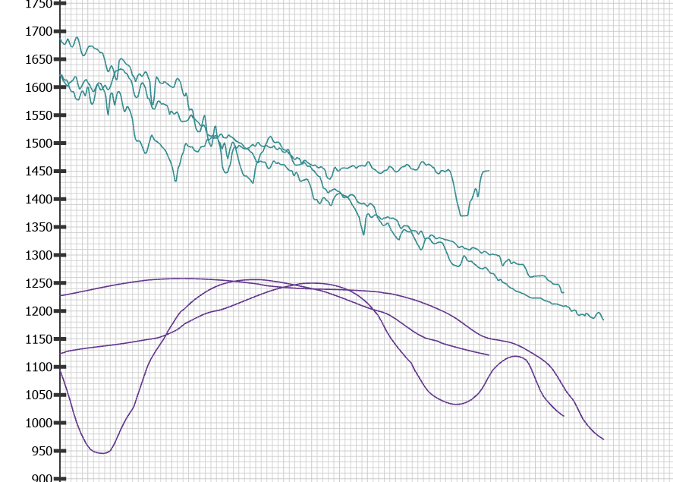

##### Troubleshooting

* If the tool fails immediately, make sure you are viewing the Map View map window.
* If it fails with errors stating “dataset does not exist or is not supported” or “the input name contains invalid characters”, rename your input rasters as described in the “Sourcing Your Data” section of this document.
* If cross section line file has an unknown spatial reference, cancel the tool and define the projection for the cross section line file.
* If cross section line file is multipart, cancel the tool and run multipart to single part.
* If any files do not get deleted and the tool crashes, make sure there are no lock files and try again.
* If [xsec_id] field is blank in any features, tool will crash. Fill in the data or delete.
* If [xsec_id] field is numeric data type instead of text, the “where” clause will not work and tool will not write and output 2D geometry. Create new cross section ID field with text data type.
* If the output has empty output fields, close your project, restart your computer, and try again.

## Verified and Unverified Wells Toolsets

In the toolbox, use the VerifiedWells toolset for verified location wells, and the UnverifiedWells toolset for unverified location wells.

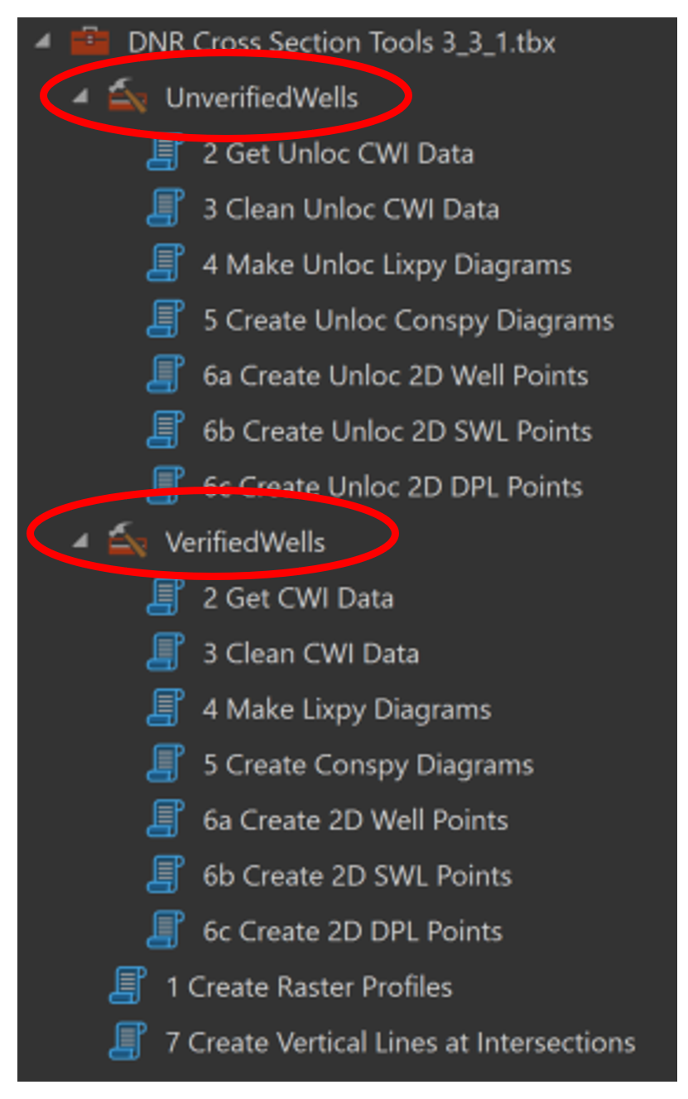

* The following instructions for tools numbered 2 through 6c with
  + Regular text indicates Inputs/Outputs for Verified wells.
  + *Italic text indicates Inputs/Outputs that differ for Unverified wells.*

**Warning!**

* The geodatabase where output data is stored MUST BE MANUALLY REFRESHED each time after running a tool.
* These tools will overwrite any existing files with the same name.
* This toolset replaces all CWI land surface elevations with land surface elevations extracted from a DEM. All other elevations values (static water level, pump level, etc.) are calculated based on the land surface elevation extracted from the DEM.

### 2 Get CWI Data / *Get Unloc CWI Data*

These tools gather CWI wells located within the specified buffer distance of each cross section line. The tools then retrieve the corresponding stratigraphy/lithology, static water level, drop pipe length, and construction data for each well. In addition, DEM elevations are extracted for each well point and added to each dataset. “MapView” map pane must be open for th

**Warning!**

* If cross section lines overlap or have overlapping buffer zones, this tool must be run separately for each cross section line. Highlight a single cross section line before running this tool.
* If cross section lines do not overlap and do not have overlapping buffer zones, all cross section lines may be run in batch.

#### Parameters

* Output geodatabase: gdb for saving output files.
* Cross section line file (mapview): cross section line(s) in map view.
* Buffer distance (in meters):
  + Rule of thumb: distances greater than ½ mile or 805 meters are not recommended.
* Land Surface DEM: Use the finest resolution DEM available. Values must be in feet. This file must be renamed to “dem” in the Contents pane or tool will fail.
* Include strat data: box is checked by default. If you do NOT want to retrieve stratigraphy data, uncheck the box.
* Include drop pipe data: box is checked by default. If you do NOT want to retrieve drop pipe data, uncheck the box.

#### Outputs (Verified)

* Wwpt: mapview Verified well points within the buffer area for selected xslns
* Xsln_buffer: polygon showing buffer area around each cross section line
* Swl: mapview well points with static water data, if available
* Data tables for wwpt wells:
  + cons: construction data
  + strat: stratigraphy and lithology data (only if box is checked)
  + dpl: drop pipe length (only if box is checked)

#### *Outputs (Unverified)*

* *Wwpt_unloc: mapview Unverified well points within the buffer area for selected cross section lines*
* *Xsln_buffer: polygon showing buffer area around each cross section line*
* *Data tables for wwpt_unloc wells:*
  + *Cons_unloc: construction data, if available*
  + *Strat_unloc: stratigraphy and lithology data, if available*
  + *Dpl_unloc: drop pipe length, if available*
  + *Swl_unloc: static water level data, if available*

##### Troubleshooting

* If mapview cross section line file has an unknown spatial reference, cancel the tool and define the projection for the cross section line file.
* If cross section line file is multipart, cancel the tool and run the “multipart to single part” tool.
* Tool will fail if there are no unverified wells within buffer distance
  + Increase buffer distance
* If tool fails to open, verify that you are using the appropriate version of ArcGIS Pro.
* If it fails because “input dataset does not exist or is not supported”
  + Refresh the .gdb where xsln_mapview file is stored
  + Verify connection to V: drive
* Missing output files
  + Check that the output correct location was entered into the tool
  + Manually refresh the output geodatabase to show new files

### 3 Clean CWI Data / *Clean Unloc CWI Data*

These tools clean and format the stratigraphy, construction, static water level and drop pipe CWI data by removing unnecessary fields and records, then adding and calculating required fields.

#### Parameters

* Output geodatabase: gdb for saving output files.
* Construction table: construction data table (“cons” or *“cons_unloc”*) produced by Get CWI Data tools.
* Drop pipe table: drop pipe data table (“dpl” or *“dpl_unloc”*) produced by Get CWI Data tools.
* Static water level points (*table*): static water level mapview points (“swl”) or table (*“swl_unloc”*) produced by Get CWI Data tools.
* Strat table: stratigraphy/lithology table (“strat” or *“strat_unloc”*) produced by Get CWI Data tools.

#### Output

* cons_clean: construction data table with only casing, screen, and open hole data (grout records as well as extra fields removed)
* dpl_clean: drop pipe mapview point feature class with extra fields removed
  + Note: records without [dropp_len] values are included in the output table
* swl_clean: swl mapview point feature class with extra fields removed and elevations calculated from DEM values.
* strat_clean: stratigraphy table with extra fields removed and elevations calculated from DEM values.
* *cons_unloc_clean: construction data table with only casing, screen, and open hole data (grout records as wells as extra fields removed)*
* *dpl_unloc_clean: drop pipe mapview point feature class*
  + *Note: records without [dropp_len] values are included in the output table*
* *swl_unloc_clean: static water level mapview point feature class*
* *strat_unloc_clean: strat data table with required fields added, extras removed*

##### Troubleshooting

* WARNING: “Certain rows set to NULL due to error while evaluating python expression: TypeError: unsupported operand type(s) for -: 'float' and 'NoneType'”
  + To fix, populate null values in ‘from_depth’ and ‘to_depth’ fields in construction table, then rerun tool.
* ERROR: “Field [xxxx] does not exist within table”
  + Verify you are using the correct input tables with the correct tool.



## REVIEW OUTPUT DATA BEFORE PROCEEDING!

The cross sections created using this tool use data from the County Well Index (CWI). The CWI database does contain errors and all information should be vetted prior to finalizing cross sections.

* “Wwpt” and *“wwpt_unloc”*
  + Do any wells need to be added?
  + Do any wells need to be removed?
  + Do any well points need to be moved to a more accurate location?
  + Does the buffer distance need to change?
* “cons_clean” and *“cons_unloc_clean”*
  + Are any records missing?
  + Are any records incorrect?
  + Note:
    - Review well log scans on [MWI](https://mnwellindex.web.health.state.mn.us/mwi/) to verify correct values.
    - Overdrills are often indicated by a record with [CONSTYPE] field value of “H” and a “Null” value in the [From_Depth] field.
* “strat_clean” and *“strat_unloc_clean”*
  + Are any records missing?
  + Are any records incorrect?
  + Note:
    - Review well log scans on [MWI](https://mnwellindex.web.health.state.mn.us/mwi/) to verify correct values.
* “swl_clean” and *“swl_unloc_clean”*
  + Are any records missing?
  + Are any records incorrect?
  + Do any well points need to be moved to a more accurate location?
  + Note:
    - Review well log scans on [MWI](https://mnwellindex.web.health.state.mn.us/mwi/) to verify correct values.
* “dpl_clean” and *“dpl_unloc_clean”*
  + Are any records missing?
  + Are any records incorrect?
  + Do any well points need to be moved to a more accurate location?
  + Note:
    - Review well log scans on [MWI](https://mnwellindex.web.health.state.mn.us/mwi/) to verify correct values.

If no changes are required, skip ahead to 4 Make Lixpy Diagrams.

### Editing Well Data

**Warning!** Only make these changes AFTER running the Clean CWI tools.

### Editing Well Locations

1. If it is determined that a well is inaccurately located, the well point can be moved in the “Map View” data frame. Start by clicking on the mapview well point layer (“wwpt” or “*wwpt_unloc”*), then open the Edit ribbon.
2. Click on the well point of interest using the **Selection** tool to highlight that point. Then click on “Move” and drag the well point to the desired location. Save edits when done.
3. While the well point has moved in the Map View, the associated coordinates have not been updated in the well point attribute table. To do this, open the attribute table and find the UTME and UTMN columns. Select the edited wells, then highlight one column at a time and select **Calculate Geometry**.
4. If updating the UTME coordinates, make sure that the “Point X-Coordinate” is indicated in the Property field. In contrast, if updating the UTMN coordinates, make sure that the “Y coordinate of Point” is indicated in the Property field.

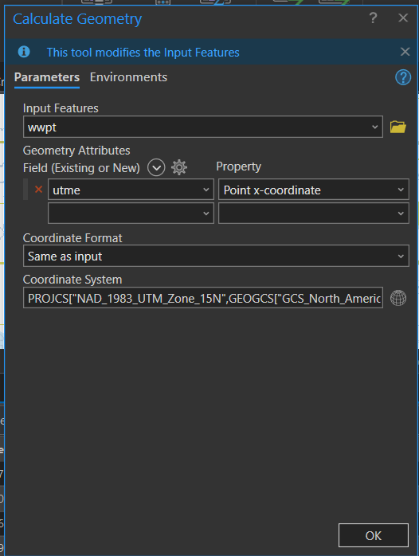

1. Make sure the “Coordinate System” is accurately identified, and “Units” should be in Meters (m). Then click **OK**. This will recalculate the UTME and UTMN coordinates based on the current location of the well point(s)
2. If the relocated well point has associated static water level and/or drop pipe length points, be sure to move those point features (“swl_clean”, “swl_unloc_clean”, “dpl_clean”, and “dpl_unloc_clean”) to same location.

### Adding New or Missing Data

In some instances, wells and/or well data are missing from the CWI database and need to be added manually. Check that the added wells are within the “xsln_buffer” polygon. If they are not within the current buffer zone, consider rerunning the Get CWI tools with a larger buffer distance that includes them.

#### Manual Data Entry

The first step is to enter the required data into the respective tables and feature classes. Either Verified or Unverified Clean CWI Data toolset outputs MUST be used, as long as all inputs for an individual well are in the same dataset (i.e. don’t mix and match between Verified and Unverified input/output files for a single well).

If required field values are missing, do not add the manual well record to file. For example, if only the surface well location, depth and static water level measurement is available, do not add new records to the stratigraphy or drop pipe tables.

##### Create manual mapview well points

1. Add the desired mapview well point file (“wwpt” or “*wwpt_unloc*”) to the MapView data frame.
2. Import or create the geometry for the missing well points in the well point file. Make sure the new well point is within the “xsln_buffer” polygon.
3. Populate the following required attribute fields for each new well:
   1. [RELATEID]: if a relateid has not yet been assigned, make up a unique one up that is 10 characters long.
      1. Starting with letters is a good way to avoid accidentally duplicating a formally assigned numeric relateid value. For example, the relateid for Test Hole 1 at Rainbow Farms could be “RFTH000001”.
   2. [DEPTH_DRLL]: depth drilled in feet
   3. [UTME]
      1. For coordinates, use **Calculate Geometry** as shown in the Edit Well Locations section above.
   4. [UTMN]
      1. For coordinates, use **Calculate Geometry** as shown in the Edit Well Locations section above.
   5. [WELL_LABEL]: Desired map and cross section label. Often the Unique ID without leading zeros.
   6. [XSEC_ID]: Cross section line ID number
   7. [BUFF_DIST]: populate with same buffer distance used in Get CWI Data tools.
   8. [dem]: land surface elevation derived from the same DEM used in Get CWI Data tools.
      1. Use the **Extract Multi Values to Points** tool in ESRI’s Spatial Analyst toolbox.
         1. Input point features: wwpt or wwpt_unloc
         2. Input rasters: “dem”
         3. Output field name: “NewField”
      2. Run the tool and note that a new field has been added to the end of the input point feature class.
      3. Select the manually added wells in the well point attribute table. Now use **Calculate Field** on the original “dem” field to transfer the values from “NewField” to “dem”.
      4. Delete the “NewField” field.
   9. [Data_Source]: “Manual” or “UserAdded”
4. When finished, click Save in the Edit ribbon.
5. To back up your edits, select the manually added wells, and export to new feature class named “wwpt_manual” or “*wwpt_unloc_manual*”, depending on which mapview well point file was added to.
   1. Building cross sections is often an iterative process. In the event the Get CWI and Clean CWI Tools need to be rerun (to change buffer zone, for instance), this ensures your manually entered data is not overwritten and can be imported to the updated well point file.

##### Create manual strat table

1. Open the desired stratigraphy attribute table (“strat_clean” or “*strat_unloc_clean*”).
2. Entering stratigraphy data from a well log:
   1. Each line of a well log that denotes a type of stratigraphy gets a record in this table.

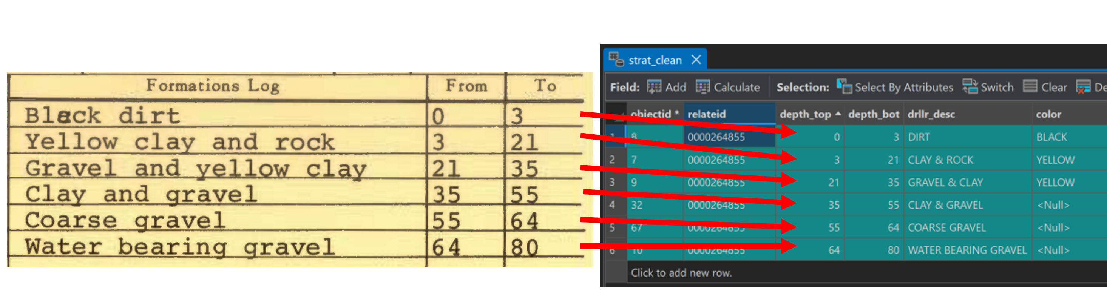

1. Create a new record for each strat record for each well and populate the following required attribute fields:
   1. [RELATEID]: unique well ID for the well the strat record is associated with. Same value as in step 3a.
   2. [DEPTH_TOP]: “From” value on well log. Depth to top of strat layer measured in feet.
   3. [DEPTH_BOT]: “To” value on well log. Depth to bottom of strat layer measured in feet.
   4. [DRLLR_DESC]: driller’s description of the stratigraphy from the well log
   5. [LITH_PRIM]: primary lithology. See Minnesota County Well Index Database Dictionary [Lithology Codes](https://mgsweb2.mngs.umn.edu/cwi_doc/lth_code.asp) Table for acceptable values.
   6. [dem]: land surface elevation for this well, same value as produced in step 3h.
   7. [ELEV_TOP]: Use **Calculate Field** tool. !dem! - !depth_top!
   8. [ELEV_BOT]: Use **Calculate Field** tool. !dem! - !depth_bot!
   9. [XSEC_ID]: Cross section line ID number
   10. [BUFF_DIST]: populate with same buffer distance used in Get CWI Data tools
   11. [Data_Source]: “Manual” or “UserAdded”
2. When finished, click Save in the Edit ribbon.
3. To back up your edits, select the manually added strat records, and export to a new table named “strat_clean_manual” or “*strat_unloc_clean_manual*”, depending on which strat table it was added to.
   1. Building cross sections is often an iterative process. In the event the Get CWI and Clean CWI Tools need to be rerun (to change buffer zone, for instance), this ensures your manually entered data is not overwritten and can be imported to the updated strat table.

##### Create manual construction table

1. Open the desired construction attribute table (“cons_clean” or “*cons_unloc_clean*”).
2. Entering construction data from a well log:
   1. Each construction type gets a record in this table.

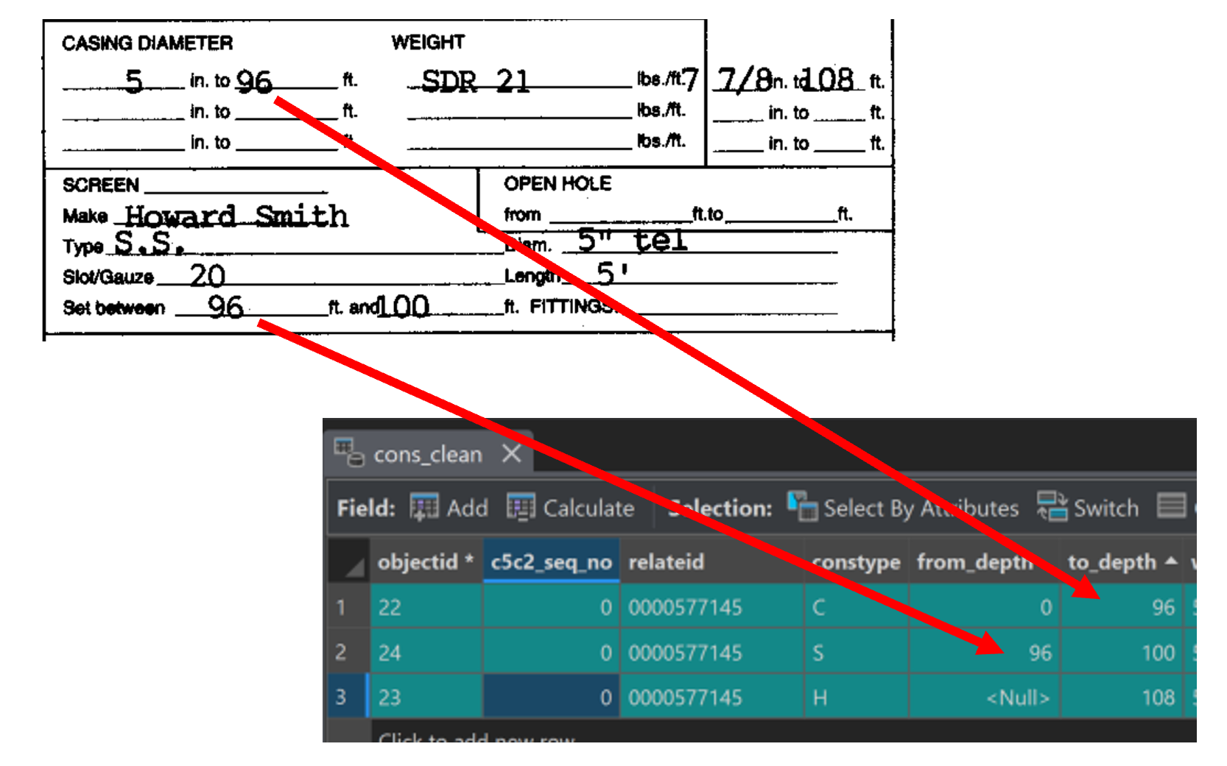

1. Populate the following required attribute fields for each construction record for each well:
   1. [RELATEID]: unique well ID for the well the construction record is associated with. Same value as in step 3a.
   2. [CONSTYPE]: “C” - Casing, “G” - Grout, “H” - Open hole, “S” - Screen
   3. [from_depth]: Top measurement of casing type
   4. [to_depth]: Bottom measurement of casing type
   5. [XSEC_ID]: Cross section line ID number
   6. [BUFF_DIST]: populate with same buffer distance used in Get CWI Data tools
   7. [dem]: land surface elevation for this well, same value as produced in step 3h.
   8. [ELEV_TOP]: Use **Calculate Field** tool. !dem! - !from_depth!
   9. [ELEV_BOT]: Use **Calculate Field** tool. !dem! - !to_depth!
   10. [Data_Source]: “Manual” or “UserAdded”
2. When finished, click Save in the Edit ribbon.
3. To back up your edits, select the manually added strat records, and export to a new table named “cons_clean_manual” or “*cons_unloc_clean_manual*”, depending on which cons table it was added to.
   1. Building cross sections is often an iterative process. In the event the Get CWI and Clean CWI Tools need to be rerun (to change buffer zone, for instance), this ensures your manually entered data is not overwritten and can be imported to the updated cons table.

##### Create manual mapview static water level points

1. Add the desired mapview static water level well point file (“swl_clean” or “*swl_unloc_clean*”) to the MapView data frame.
2. Import or create the geometry for the missing static water level points in the mapview point file. Make sure the new points are within the “xsln_buffer” polygon and snapped to the corresponding well in “wwpt” or “*wwpt_unloc*”.
3. Populate the following required attribute fields for each new record:
   1. [RELATEID]: same value as in step 3a.
   2. [Measuremt]: depth to water in feet
   3. [dem]: land surface elevation for this well, same value as produced in step 3h.
   4. [meas_elev]: Use **Calculate Field** tool. !dem!-!measuremt!
   5. [XSEC_ID]: Cross section line ID number
   6. [BUFF_DIST]: populate with same buffer distance used in Get CWI Data tools.
   7. [Data_Source]: “Manual” or “UserAdded”
4. When finished, click Save in the Edit ribbon.
5. To back up your edits, select the manually added static water level points, and export to new feature class named “swl_clean_manual” or “*swl_unloc_clean_manual*”, depending on which mapview well point file was added to.
   1. Building cross sections is often an iterative process. In the event the Get CWI and Clean CWI Tools need to be rerun (to change buffer zone, for instance), this ensures your manually entered data is not overwritten and can be imported to the updated swl point file.

##### Create manual mapview drop pipe length points

1. Add the desired mapview drop pipe length point file (“dpl_clean” or “*dpl_unloc_clean*”) to the MapView data frame.
2. Import or create the geometry for the missing drop pipe length points in the mapview point file. Make sure the new points are within the “xsln_buffer” polygon and snapped to the corresponding well in “wwpt” or “*wwpt_unloc*”.
3. Populate the following required attribute fields for each new record:
   1. [RELATEID]: same value as in step 3a.
   2. [DROPP_LEN]: depth to pump in feet
   3. [dem]: land surface elevation for this well, same value as produced in step 3h.
   4. [XSEC_ID]: Cross section line ID number
   5. [Data_Source]: “Manual” or “UserAdded”
4. When finished, click Save in the Edit ribbon.
5. To back up your edits, select the manually added drop pipe length points, and export to new feature class named “dpl_clean_manual” or “*dpl_unloc_clean_manual*”, depending on which mapview well point file was added to.
   1. Building cross sections is often an iterative process. In the event the Get CWI and Clean CWI Tools need to be rerun (to change buffer zone, for instance), this ensures your manually entered data is not overwritten and can be imported to the updated dpl point file.

### Removing Wells

To remove a well so that it is not added to the cross section plot, delete the well’s records in the following files:

* “wwpt” or *“wwpt_unloc”*
* “swl_clean” or *“swl_unloc_clean”*
* “dpl_clean” or *“dpl_unloc_clean”*
* Note: Records associated with the deleted well will remain in the stratigraphy and construction tables; however, the data will not be plotted.

## For Combined Verified and Unverified 2D Outputs

Combining Verified and Unverified data can make cross section formatting and symbology easier. If you would like to do this, it is best to append Unverified input files to Verified input files BEFORE using tools 4-6c to produce 2D files. Merging or appending 2D files after running tools 4-6c often results in errors and missing data.

The first input file to combine for Verified tool 4 will be used in the following steps; however, these same steps can be used to combine any of the input files for Verified tools 4-6c. Reference table provided below for combining other 2D tool input files.

1. Create a copy of “wwpt” and name it “wwpt_combined”.
2. Right click on “wwpt_combined” and select Load Data. In the Append window:
   1. Input Dataset: “wwpt_unloc”
   2. Target Dataset: “wwpt_combined”

* Field Matching Type: Use the field map to reconcile field differences
* Not all fields will have matches; ignore those. Click Run.

1. Use “wwpt_combined” as well point file input for tools 4-6c.

Table 1 Reference for Combining Other 2D Tool Inputs

|  |  |  |  |  |
| --- | --- | --- | --- | --- |
| File to Copy | New File Name | Append: Input Dataset | Append: Target Dataset | For use in Tool |
| Wwpt | wwpt_combined | wwpt_unloc | wwpt_combined | 4 Make Lixpy Diagrams, 5 Make Conspy Diagrams, 6a Create 2D Well Points |
| Strat_clean | strat_clean_combined | strat_unloc_clean | strat_clean_combined | 4 Make Lixpy Diagrams |
| Cons_clean | Cons_clean_combined | Cons_unloc_clean | cons_clean_combined | 5 Make Conspy Diagrams |
| Swl_clean | swl_clean_combined | swl_unloc_clean | swl_clean_combined | 6b Create 2D SWL Points |
| Dpl_clean | dpl_clean_combined | dpl_unloc_clean | dpl_clean_combined | 6c Create 2D DPL Points |

### 4 Make Lixpy Diagrams/ *Make Unloc Lixpy Diagrams*

These tools create well stick diagrams based on a stratigraphy and lithology table, well point location feature class, and mapview cross section line feature class.These tools may take a few minutes to run depending on number of stratigraphy records.

#### Parameters

* Output geodatabase: gdb for saving output files.
* Cleaned strat table: strat produced by Clean CWI Data tool (“strat_clean” or “*strat_unloc_clean*”)
* Well point file: point feature class that contains mapview well locations (“wwpt” or “*wwpt_unloc*”)
* Cross section line file (mapview): cross section lines in mapview (“xsln_mapview”)
* Cross section line ID field: field in cross section line that contains unique cross section ID number.
* Cross section ID field in well point file: field in “wwpt” or “*wwpt_unloc”* that contains cross section number that matches number in cross section line file.
* Well ID field in stratigraphy table: [relateid]
* Well ID field in well point file: [relateid]
* Buffer distance (in meters): must match value used in Get CWI Data tools.
* Vertical exaggeration factor: must match value used in Create Raster Profiles tool.
* Well stick width: default value is 0.5, can be increased up to 5 for longer cross sections.
* Output 2D coordinate system: Projected coordinate system for 2D output in cross section view (Projected 2D Coordinate System)

#### Output

* Lixpy_2d_poly: unprojected lithology polygons for 2D well sticks (Unknown Coordinate System)
* Lixpy_2d_poly_prj: projected lithology polygons for 2D well sticks (Chosen Projected 2D Coordinate System)
* *Lixpy_unloc_2d_poly*: unprojected lithology polygons for 2D unverified well sticks (Unknown Coordinate System)
* *Lixpy_unloc_2d_poly_prj*: projected lithology polygons for 2D unverified well sticks (Chosen Projected 2D Coordinate System)

##### Troubleshooting

* If it runs really slowly, make sure all input data is on a local drive and try again.
* If correct fields don’t exist, the tool will fail. Change the field names (not alias) to match the error message. Calculate fields as needed.
* Some well sticks are missing from the output polygons.
  + The [xsec_id] in strat table/well points don’t match the input cross section [xsec_id]. Edit the [xsec_id]s to match.

### 5 Create Conspy Diagrams / *Create Unloc Conspy Diagrams*

These tools create well stick diagrams based on a cleaned well construction table, well point location feature class, and mapview cross section line feature class.This tool may take some time depending on number of construction records.

#### Parameters

* Output geodatabase: gdb location for saving output files.
* Cleaned cons table: gdb table that contains cleaned construction data (“cons_clean” or “*cons_unloc_clean*”)
* Well point file: point feature class that contains mapview well locations (“wwpt” or “*wwpt_unloc*”)
* Cross section line file (mapview): cross section lines in map view.
* Cross section line ID field: field in cross section line that contains cross section number.
* Cross section ID field in well point file: field in “wwpt” or “*wwpt_unloc”* that contains cross section number that matches number in cross section line file.
* Well ID field in cons table: field that is used to relate construction table and well point file to each other [relateid]
* Well ID field in well point file: [relateid]
* Buffer distance (in meters): must match value used in Get CWI Data tools.
* Vertical exaggeration factor: must match value used in Create Raster Profiles tool.
* Well stick width: default value is 0.5, can be increased up to 5 for longer cross-sections.
* Output 2D coordinate system: Projected coordinate system for 2D output in cross section view (Projected 2D Coordinate System)

#### Output

* Conspy_2d_poly: unprojected construction polygons for 2D well sticks (Unknown Coordinate System)
* Conspy_2d_poly_prj: projected construction polygons for 2D well sticks (Chosen Projected 2D Coordinate System)
* *Conspy_unloc_2d_poly*: unprojected construction polygons for 2D unverified well sticks (Unknown Coordinate System)
* *Conspy _unloc_2d_poly_prj*: projected construction polygons for 2D unverified well sticks (Chosen Projected 2D Coordinate System)

##### Troubleshooting

* If it runs really slowly, make sure all data is on a local drive and try again.
* Some well sticks are completely missing from the output polygons.
  + The [xsec_id] in construction table and or well points may not match the input cross section [xsec_id]. Edit the [xsec_id]s to match.

### 6a Create 2D Well Points / *Create Unloc 2D Well Points*

These tools create 2D well points at ground elevation in cross-section view based on a well point location feature class, and mapview cross section line feature class.

#### Parameters

* Output geodatabase: gdb location for saving output files.
* Well point file: point feature class that contains mapview well locations (“wwpt” or “*wwpt_unloc*”)
* Cross section line file (mapview): cross section lines in map view.
* Cross section line ID field: field in cross section line that contains cross section number.
* Cross section ID field in well point file: field in “wwpt” or “*wwpt_unloc”* that contains cross section number that matches number in cross section line file.
* Well ID field in well point file: [relateid]
* Buffer distance (in meters): must match value used in Get CWI Data tools.
* Vertical exaggeration factor: must match value used in Create Raster Profiles tools.
* Well label field in well point file: field for labeling output points. Often [well_label], which contains the unique well ID without the leading zeros.
* Output 2D coordinate system: Projected coordinate system for 2D output in cross section view (Projected 2D Coordinate System)

#### Output

* Wwpt_2d_xsecview: unprojected point file for cross-section viewing (Unknown Coordinate System)
* Wwpt_2d_xsecview_prj: projected point file for cross-section viewing (Chosen Projected 2D Coordinate System)
* *Wwpt_unloc_2d_xsecview*: unprojected point file for cross-section viewing (Unknown Coordinate System)
* *Wwpt_unloc_2d_xsecview_prj*: projected point file for cross-section viewing (Chosen Projected 2D Coordinate System)

##### Troubleshooting

* Well points are appearing over blank spaces. Check that lithology and construction data exists for these wells.

### 6b Create 2D SWL Points / *Create Unloc 2D SWL Points*

These tools create 2D points at static water level (SWL) elevations in cross section view based on a mapview static water level point feature class, and mapview cross section line feature class.

#### Parameters

* Output geodatabase: gdb location for saving output files.
* Cleaned static water level point file: point feature class that contains well locations and swl elevations (“swl_clean” or “*swl_unloc_clean*”)
* Cross section line file (mapview): cross section lines in map view.
* Cross section line ID field: field in xsln_mapview that contains cross section number.
* Cross section ID field in static water level point file: field in “swl_clean” or “*swl_unloc_clean*” that contains cross section number that matches number in cross section line file.
* Well ID field in static water level well point file: [relateid]
* Buffer distance (in meters): must match value used in Get CWI Data tool.
* Vertical exaggeration factor: must match value used in Create Raster Profiles tool.
* Output 2D coordinate system: Projected coordinate system for 2D output in cross section view (Projected 2D Coordinate System)

#### Output

* swl_2d_xsecview: unprojected point file for cross-section viewing (Unknown Coordinate System)
* swl_2d_xsecview_prj: projected point file for cross-section viewing (Chosen Projected 2D Coordinate System)
* *Swl_unloc_2d_xsecview*: unprojected point file for cross-section viewing (Unknown Coordinate System)
* *Swl_unloc_2d_xsecview_prj*: projected point file for cross-section viewing (Chosen Projected 2D Coordinate System)

##### Troubleshooting

* Water level points are missing. Check that there are SWL records with elevations (meas_elev) for these wells and the measurement values are not null or zero.
* Water level points are in the incorrect locations. Check that you used the correct input files.

### 6c Create 2D DPL Points / *Create Unloc 2D DPL Points*

These tools create 2D well points at pump or drop pipe elevations in cross-section view based on a mapview DPL well point location feature class, and mapview cross section line feature class.

#### Parameters

* Output geodatabase: gdb location for saving output files.
* Cleaned drop pipe length point file: mapview point feature class that contains well locations and drop pipe lengths.
* Cross section line file (mapview): cross section lines in map view.
* Cross section line ID field: field in cross section line that contains cross section number.
* Cross section ID field in drop pipe length point file: field in “dpl_clean” or “*dpl_unloc_clean”* that contains cross section number that matches number in cross section line file.
* Well ID field in drop pipe length point file: [relateid]
* Buffer distance (in meters): must match value used in Get CWI Data tool.
* Vertical exaggeration factor: must match value used in Create Raster Profiles tool.
* Output 2D coordinate system: Projected coordinate system for 2D output in cross section view (Projected 2D Coordinate System)

#### Output

* dpl_2d_xsecview: unprojected point file for cross-section viewing (Unknown Coordinate System)
* dpl_2d_xsecview_prj: projected point file for cross-section viewing (Chosen Projected 2D Coordinate System)
* *dpl_unloc_2d_xsecview*: unprojected point file for cross-section viewing (Unknown Coordinate System)
* *dpl_unloc_2d_xsecview_prj*: projected point file for cross-section viewing (Chosen Projected 2D Coordinate System)

##### Troubleshooting

* Well points are missing. Check that there are DPL records for these wells.

## Extras

This tool is optional to use and may provide helpful context to cross-sections.

### 7 Create Vertical Lines at Intersections

This tool plots vertical lines in cross section view at the locations of a cross section’s intersection with features such as roads, waterbodies, municipal or county boundaries, etc. You may either use and label the lines as they are, or temporarily use them to place annotation indicating the feature of interest.

This tool does not include features that are within the buffer zone that DO NOT cross the cross section line. If you would like to plot these features:

1. Create a new line feature class and digitize lines from the feature(s) of interest to the cross section line at a 90 degree angle. Make sure the line crosses or is snapped to the cross section line.
2. Be sure to add a “Name” field to the feature class and enter the feature’s name.
3. Run the Create Vertical Lines at Intersections tool.

#### Parameters

* Output geodatabase: gdb location for saving output files.
* Cross section line file (mapview): cross section lines in map view.
* Cross section line ID field: field in xsln that contains cross section number.
* Feature Class to Intersect: can be point, line, or polygon in mapview
* Vertical exaggeration factor: must match value used in other tools
* Output line feature class: name appropriately and save in the project’s default gdb.
* Output 2D coordinate system: Projected coordinate system for 2D output in cross section view (Projected 2D Coordinate System)

#### Output

* Line feature class in 2D cross section view

##### Troubleshooting

* If the tool fails, it may be due to spaces or special characters in the input layer name entered in “Feature Class to Intersect”. Rename the layer in the table of contents and try running again.

## Formatting the Cross sections

### Protecting Non-public Information

DNR has access to NON‐PUBLIC information for community water supplies in the CWI database file. DNR is NOT permitted to share this information with the public without the consent of the Minnesota Department of Health (MDH). Be sure to obscure the locations of these wells with polygons in your Map View before disseminating.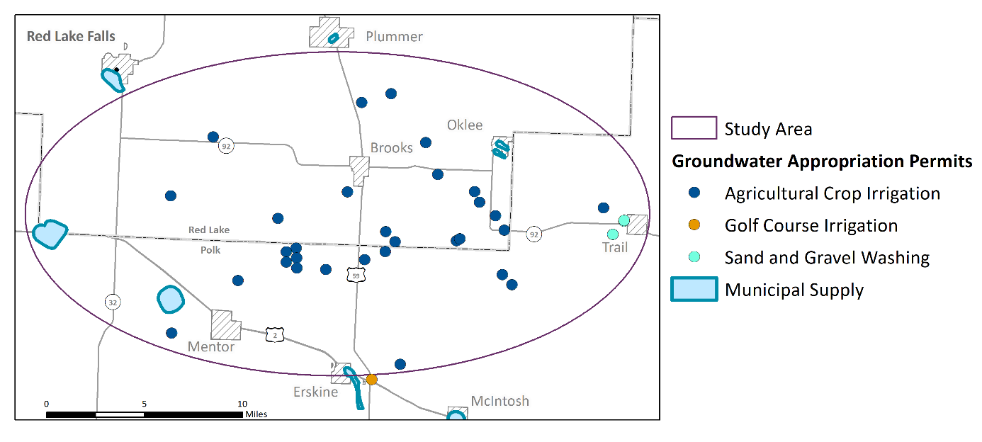

### Editing 2D Output Files

* The cross section view map pane must be set to the same 2D projected coordinate system as the 2D output files.
* Only files with projected 2D coordinate systems can be edited (e.g. files ending in “_prj”).

**Symbolize and label the wells in cross section view**

1. Right‐click on the “wwpt_2d_xsecview_prj” file and select Symbology**.**
2. In the Symbology pane, click on the point symbol on the Primary symbology tab.
3. The Gallery will open. Go to the Properties tab of the Symbology pane. Change the shape colors to “no color” and click Apply.
4. Open the attribute table, and use Calculate Field to copy the values from whichever field you’d like to label the wells with to the [well_label_2d] field. The [well_label_2d] field length is longer and has more room for details, if needed.

* Now click on the Labeling ribbon. On the left-hand side of the ribbon, check the box for “Label Features in this class”, and change the Field to ‘well_label_2d’.
* Turn on Maplex Label Engine by going to Labeling ribbon > “Map” section > “More” drop down menu and selecting “Use Maplex Label Engine”
* To center the well label above the well, and to orient it in the vertical direction, open the Label Placement menu.

1. In the Label Class pane, open the Position tab and expand the Placement header. Choose Top of Point for placement. Change the Preferred Offset to 5 points.

* Now expand the Rotation header. Change the Additional Rotation value to 90.

1. In the Label Class pane, open the Conflict Resolution tab and expand the Unplaced Labels header. Check the box for Never remove (place overlapping).
2. To manipulate and save labels, convert labels to either Annotation or Graphics.

### Format the well construction file

* To format the well construction information, open the symbology menu for the “conspys_2d_poly_prj” file.

1. Change Primary Symbology to Unique Values, and Field 1 to [constype].

#### Caution!

* + Sometimes the well casing or screen information is missing from CWI. This can be very apparent when looking at the cross sections. If the well casings or well screens do not appear, you will need to go back and repeat some of the earlier steps. These include:
    - Opening up the cons_clean table and manually adding the casing, and screen information in the appropriate fields.
    - Rerunning the Create Conspy Diagrams tool to create a new set of conspy well stick files.
  + NOTE: This can be avoided if you carefully screen the cons_clean database tables prior to creating the conspy polygon files.

### Format Verified well lithology file

* Open the symbology menu for the lixpys_2d_poly_prj” file.

1. Change Primary Symbology to Unique Values, and Field 1 to [lith_prim].

* Review the [lith_prim] values that appear. Some examples of naming issues to be aware of include:
  + Gravel may be spelled: GRAVEL, GRVL, GRVE, etc.
  + Combinations of lithology types may be reported as: Sand/Clay, Clay/Sand, Sand & Clay, Sandy Clay.
    - Be careful because SAND and SNDS are two different things. SNDS = Sandstone. *Remember, you can review the CWI naming schemes and codes on the* [*Minnesota County Well Index Database Dictionary Table: LTH_CODE webpage*](https://mgsweb2.mngs.umn.edu/cwi_doc/lth_code.asp)*.*

1. To modify the pattern fill or color, click on and format each of the colored boxes in the TOC. Modify the fill colors and patterns as desired. Note that the well construction outlines (casing, screen, etc.) will be laid over these lithology files but their transparency allows you to visualize the lithology. When finished, click on **Apply.**

#### Caution!

* Work with your Groundwater Specialist/ Professional Geoscientists on staff to determine how these lithologies should be renamed or grouped for the purposes of reporting names in the legends for the project cross section(s). Be clear and consistent with the language in the text of the report.

### Format the Unverified and Combined well lithology files

Unverified wells do not have assigned [lith_prim] values. Lithology is reported in the [drllr_desc] field. There are a number of approaches to reconciling the two fields for symbolization. All of them require the use of your professional judgement as a geologist.

* Manually enter [lith_prim] values for all unverified well lithology records. Note that this field can only hold 4 characters. Use the [CWI “Lith_Code” as a guide.](https://mgsweb2.mngs.umn.edu/cwi_doc/lth_code.asp)
* Create a new interpreted lithology Text field with a length of 255 characters named “Interp_Lith” and populate it according to your interpretation of [lith_prim] and [drllr_desc] field values.
* Use “Group Values” in the symbology menu to group similar lithologies.
* Open the Symbology menu for combined lithology “lixpy_2d_poly_prj” file.
* Change Primary Symbology to Unique Values, and set
* Field 1 to [lith_prim]
* Field 2 to [lith_sec]
* Field 3 to [drllr_desc]
* Review the values in the symbol classes, and group similar values.

However you choose to reconcile the differing fields, make sure the Label for each symbol class is in clean and concise.Add the static water level elevations

1. Add “swl_2d_xsecview_prj” to the TOC in the “Cross Section” map view.
2. Review these points to ensure that they are overlapping or slightly offset with your well sticks at the appropriate elevation.

### Add the pump setting information

1. Add “dpl_2d_xsecview_prj” to the TOC in the “Cross Section” map view.
2. Review these points to ensure that they are overlapping or slightly offset with your well sticks at the appropriate elevation.

### Create polylines or polygons to illustrate lithology

In addition to viewing the lithology in a well, you may also want to depict surface waterbodies, or to connect the sand or clay layers using lines or polygons.

* Create a new line or polygon Feature Class in your project geodatabase. Add the new file(s) to the Cross Section View map frame and digitize lines or polygons as needed.

Examples of how lines and polygons can be used to illustrate subsurface lithology are shown below.

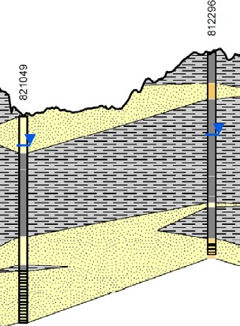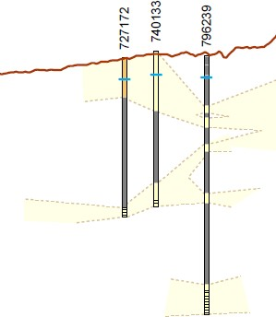

#### Caution!

* + Sometimes well sticks overlap. To move them, open an Edit session for lixpys_2d_poly in cross section view, select by RELATEID, then drag to the side with the editor tool and save your edits. Create annotation indicating which well was moved.
  + Lines connecting lithology in the wells should be dashed when the lithology between the wells is not clearly known.
  + Connecting the dots is not as easy as one might think. Geologic processes that would have deposited or formed the lithologic layers at this site will inform how you illustrate the cross-section lines.
  + In the State of Minnesota, all cross section that include geologic or hydrogeologic interpretations are required to be developed under a licensed Professional Geoscientist (PG).

### Format the legend

Remember that the file names may not be plain language. Please format the legend names so that they are clear and concise for the audience. Also make sure these labels are consistent with the text in any associated report.

### Format the Cross Section PDF

All cross sections should include:

* + Title
  + Legend
  + X and Y axes with labels
  + Vertical Exaggeration
  + Creator and Date Created
  + Map inset (or associated map view PDF)
    - Scale bar and north arrow

#### Accessibility

Due to the large amount of effort associated with making exported pdfs of the cross sections and maps accessible, it is recommended that these visuals be exported as JPGs from ArcMap. These JPGs can be added as images to Word documents. Adding Alt Txt to these images makes them accessible.